Badge | How to earn this badge | Number of Points
Gold Chapter Badge | Earn a 95% or higher on the chapter test | 5 points
Silver Chapter Badge | Earn a 90% or higher on the chapter test | 3 points
Bronze Chapter Badge | Earn an 80% or higher on the chater test | 1 point
Notes 1 | Create a notebook with the following sections : Notes, Dictionary, Verbs, Graded Assignments | 1 point
Notes 2 | Pass Notebook Midterm Inspection : Materials need to be in the appropriate sections | 2 points
Notes 3 | Pass Notebook Final Inspection :  Materials need to be in the appropriate sections | 3 points
Lexiphile 1 | Adds 25 words to your dictionnary | 1 point
Lexiphile 2 | Adds 50 words to your dictionnary | 2 points
Lexiphile 3 | Adds 100 words to your dictionnary | 3 points
Lexiphile 4 | Adds 175 words to your dictionnary | 4 points
Lexiphile 5 | Adds 250 words to your dictionnary | 5 points
« Culture » Box | Complete the chapter culture activity | 1 point per box
« Lieu » Box | Complete the place introduction | 1 point per box
« Fêtes » Box | Complete the holiday activity | 1 point per box
Café Au lait | Try « café au lait” | 2 points
Palais | Score 90% or higher on a diagram and description of a room in Versaille. | 2 points
Recette | Score 90% or higher on your recipe presentation | 2 points
Asterix | Score 90% or higher on your comic | 2 points
Legend | Score 90% or higher on your Legend | 2 points
Art | Score 90% or higher on the Art Poster | 2 points
Explorer | Complete the scavanger hunt | 2 points
Miroir | Complete assigned reflection | 2 points per reflection
étoile 1 | Read and Summarize a current event in French | 3 ponts
étoile 2 | Signed up for duolingo | 3 points
Je suis bien préparé pour français II ! | Earn 50 points or more from badges | Signifies ready for French II  (See Madame)
Pencil to keep = 2 points Speak English Pass = 2 points Homework pass = 5 points
3 stars on test = 5 points Lunch In Pass = 10 points Free Study Day = 10 points
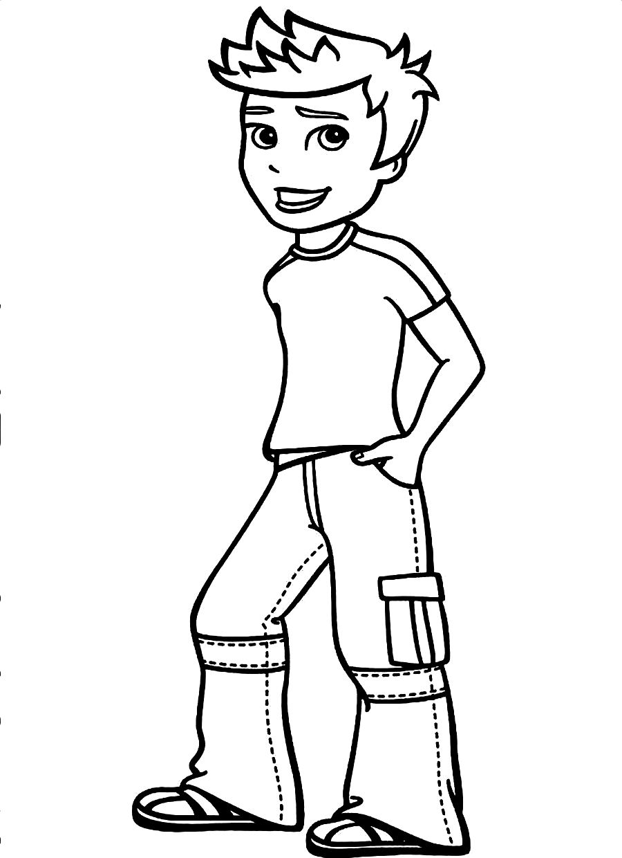
2
1
Café
Au
lait

explorer

Je suis bien préparé pour français II !
lexiphile
2

lexiphile
1

lexiphile
3

palais

recette

art

asterix

legende

Miroir
1

Miroir
3

Miroir
4

Miroir
2

Fêtes
5

notes
1

notes
2

notes
3

Lieu
3

Culture
5

lexiphile
4

lexiphile
5

Chapitre
1
Chapitre
3

Chapitre
2

Chapitre
4

Chapitre
5

Nom: _________________

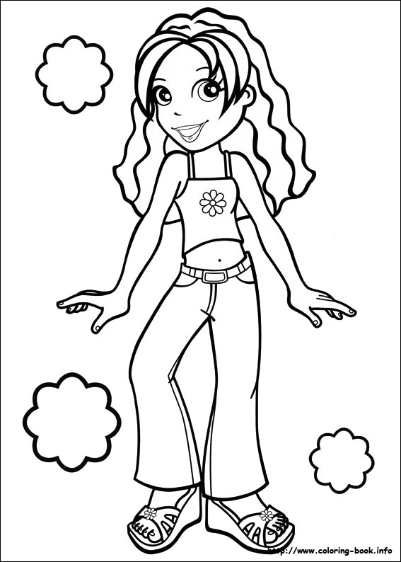

recette

palais

asterix

legende

art

explorer

Café
Au
Lait
1
2
Miroir
4

Miroir
2

Miroir
3

Miroir
1

Nom: _________________
Chapitre
2

Chapitre
1
Chapitre
4

Je suis bien préparée pour français II !
notes
3

notes
2

notes
1

culture
5

Fêtes
5

lieu
3

lexiphile
5

lexiphile
4

lexiphile
1

lexiphile
3

lexiphile
2

Chapitre
5

Chapitre
3

Pal
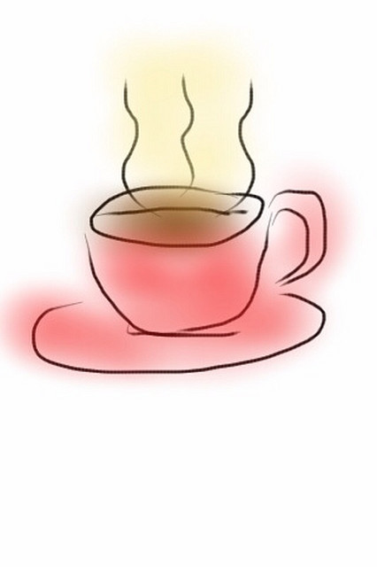
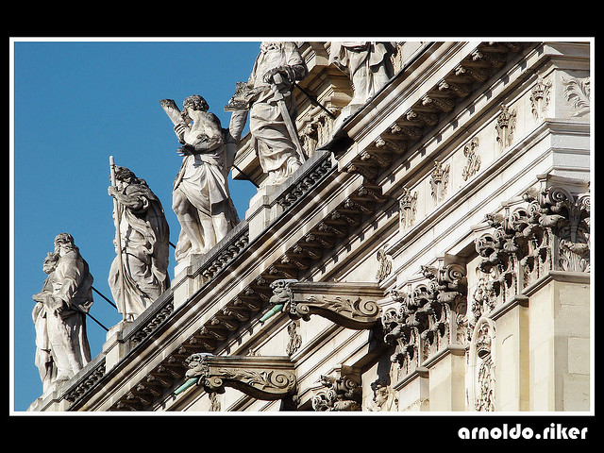
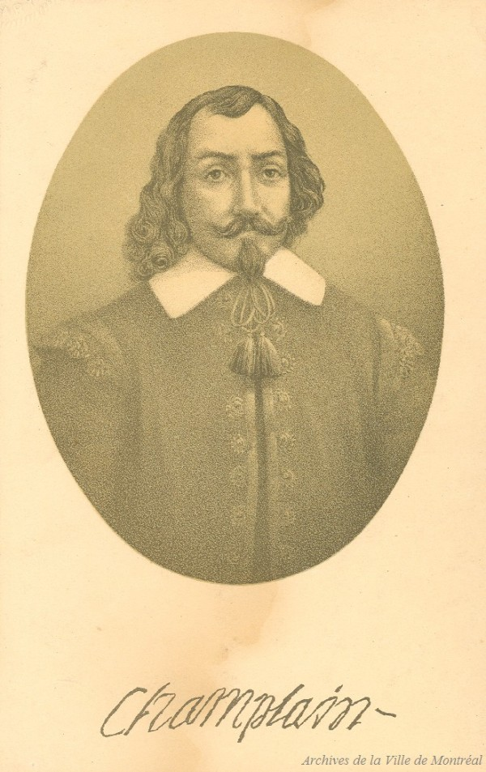
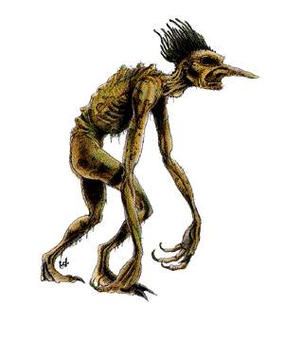

v
v
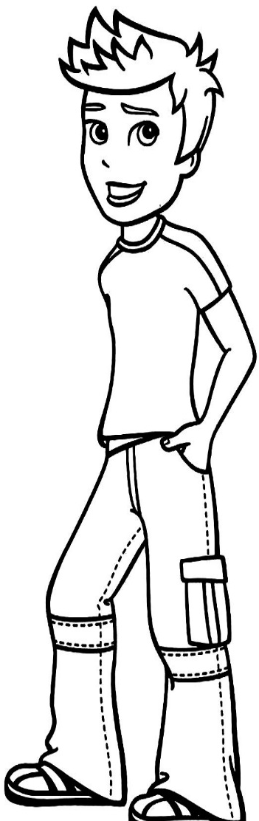
Chapt 4

Chapt 1
Chapt 3

Chapt 2

Chapt 5

Chapt 4

Chapt 5

Chapt 3

Chapt 2

Chapt 1
Chapt 1
Chapt 3

Chapt 2

Chapt 5

Chapt 4

Chapt 1
Chapt 3

Chapt 2

Chapt 5

Chapt 4

Chapt 4

Chapt 5

Chapt 2

Chapt 3

Chapt 1
Chapt 1
Chapt 3

Chapt 2

Chapt 5

Chapt 4

1
1
1
1
1
1
1
1
1
1
1
1
1
1
1
1
1
1
2
2
2
2
2
2
2
2
2
2
2
2
2
2
2
2
2
2
2
2
2

