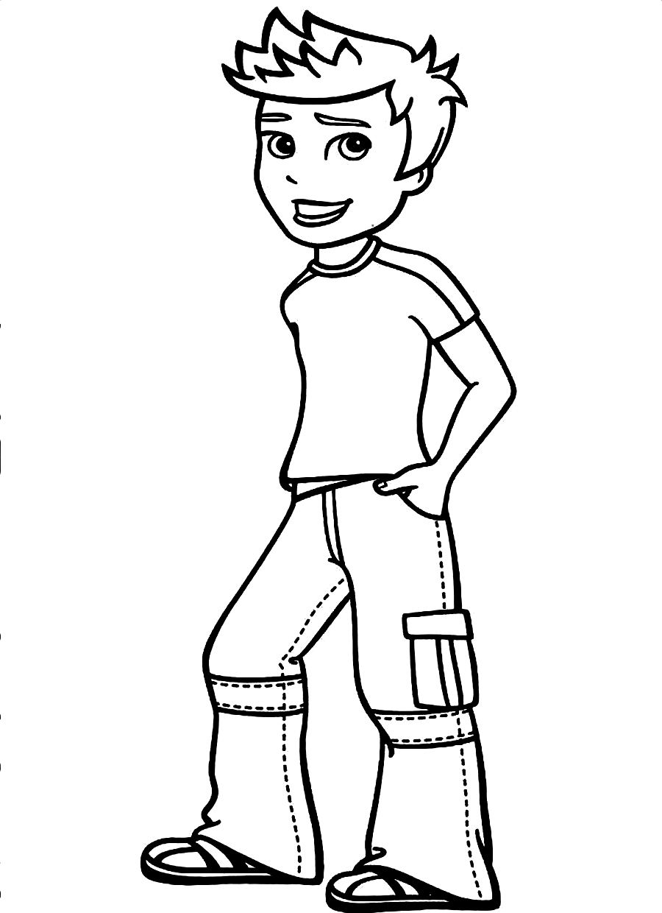

2

1

Nom: ______________­___

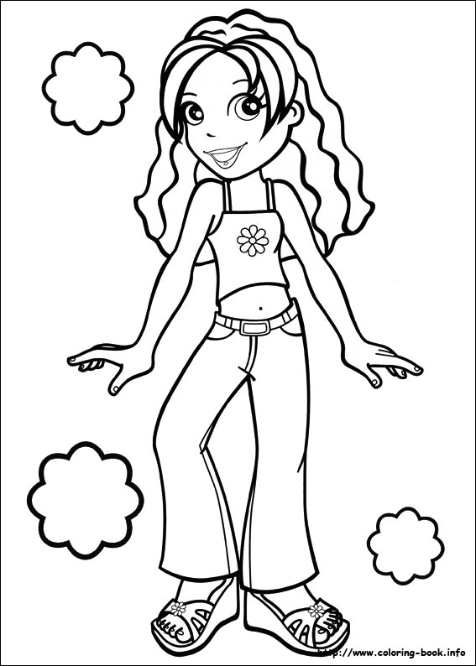

1

2

Nom: _________________

pal

